TEST 1 - Đáp án  Time: 120 minutes | SCORE: Vocabulary 25  Listening 15  Pronunciation 10  Translation 32  Speaking 18  TOTAL 100

A. Vocabulary:
🔗 EXERCISE 1 (25 words = 12.5 points): Listen and note down the words/phrases you hear from the recording (Save the Definition for later when the recording is finished)
somebody = sb / something = sth
# | Word/Phrase | Definition
1 | outgoing | hướng ngoại
2 | environment | môi trường
3 | Go out to eat | đi ăn ngoài
4 | It takes how much time to do something (sth) | mất bao nhiêu thời gian để làm gì
5 | Routine | thói quen (hàng ngày)
6 | Review one’s study notes | Ôn lại bài học (phần ghi chép)
7 | Get stuck | Bị kẹt
8 | Traffic jam | tắc đường
9 | Regular schedule | lịch đều đặn, thường xuyên
10 | Catch up with each other | cập nhật về đời sống của nhau
11 | Convenient | thuận tiện
12 | In one’s free time | trong thời gian rảnh
13 | Take the bus | bắt xe buýt
14 | Pitch in to help somebody | mỗi người một tay một chân giúp đỡ
15 | Go to the gym | đi tập gym
16 | A big fan of something | thích một cái gì đó
17 | Broaden my knowledge | mở rộng kiến thức (của tôi)
18 | Most of my time | hầu hết thời gian (của tôi)
19 | Work hard | làm việc chăm chỉ
20 | Latest book | quyển sách mới ra
21 | Get together | tụ tập
22 | Places of interest | địa điểm thu hút khách du lịch
23 | Be involved in | liên quan đến, là một phần của cái gì
24 | Combine something | kết hợp
25 | Sign up for guided tours | đăng ký các tour có hướng dẫn viên

EXERCISE 2 (25 words = 12.5 points): PICTORIAL WORDS: Look at the pictures and write down the words/ phrases they represent
(Chú ý: không dùng 1 từ cho 2 bức tranh khác nhau)
The c_ _ _ _ _ _ _ leads to three doors.  Note: lead (v): dẫn đến | The two girls love to g_ _ _ _ _  a_ _ _ _ their friends’ lives. | 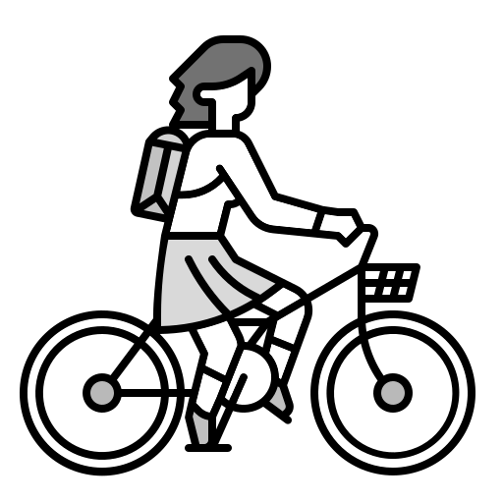I often  r___ m_ b___ t_ s_____ | She sent a s_____ in the Messenger app on her phone. | Every morning, I h___ _ c__ __ c_____  before going to work
1. Corridor | 2. Gossip about | 3. Ride my bike to school | 4. Smiley | 5. Have a cup of coffee
  I usually r____ after school. |   He can c__________ when he studies. |   He is so s_______ with his work. |   She likes to t___ p__________ of beautiful sceneries |   I often w___ u_ at 6:30 p.m.
6. Relax | 7. Concentrate | 8. Stressed | 9. Take photographs | 10. Wake up
  I sometimes g_ f__ _ w___ on the weekend to relax. |   Hồ Gươm is a l____ place of interest. |   He loves to s___ k______ |   I rarely w___ d_____ after meals |   My friends are really s_______. They love to hang out with me.
11. Go for a walk | 12. Local | 13. Sing karaoke | 14. Wash dishes | 15. Sociable
  VinMart is a kind of mini s__________ |   He doesn’t play sports d_____ t__ w___ |   They often d______ problems in the meeting. |   I always h___ o__ w___ f______ in my free time. |   I usually g_ s__________ on holiday
16. Supermarket | 17. During the week | 18. Discuss | 19. Hang out with friends | 20. Go sightseeing
  He has to w___ o_______ at work and he is tired | 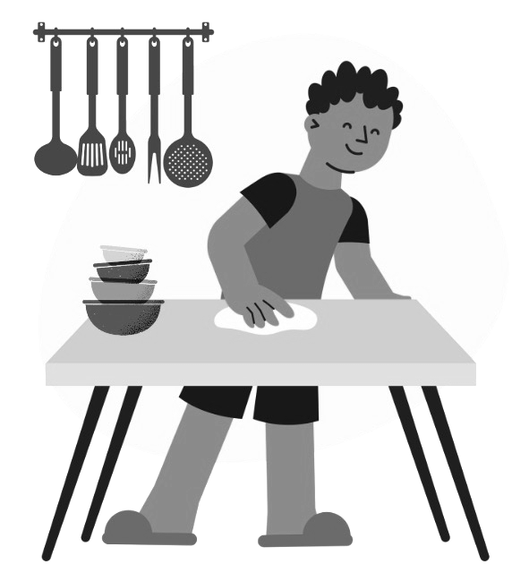  I sometimes c____ t__ t____ after dinner. |   A car is a m____ o_ t________ |   The class starts at nine  o’_____ s____ |   My friends sometimes b__ s_____ to eat during break times.
21. Work overtime | 22. Clear the table | 23.Means of transport | 24. O’ clock sharp | 25. Buy snacks

B. Listening:
🔗 EXERCISE 3 (15 items= 15 points): Listening
Part 1 - American families today
Listen and order the sentences from A to E. You have 30 seconds to read the questions (nghe và sắp xếp trật từ cho câu A đến câu E. Bạn có 30s để đọc câu hỏi)
1 - A. American families are changing from the way they used to be.
5 - B. Many US marriages end in divorce, and many people stay single.
3 - C. The changing family types.
4 - D. An explanation for the decrease in traditional families is the greater number of working women.
2 - E. The main difference is that families are smaller.

Part 2 – My favourite teacher
Listen and complete the table below. (WRITE ONE WORD ONLY for each answer.)
You have 60 seconds to read the questions.
Nghe và hoàn thành bảng (CHỈ ĐIỀN MỘT TỪ DUY NHẤT). Bạn có 60 giây để đọc câu hỏi)

My favorite teacher - Mr. Lambert
His appearance | - dark hair  - short legs  - thick beard
His teaching style | - brings energy to the class  - always look for new ways of teaching to communicate ideas  - does not use (2) English in his French classes
An unforgettable experience | Once, he used a desk, a blackboard and a (3) wastebasket to communicate the word “above”. The students loved it as he was really (4) excited about teaching it.
Why he is loved by students | When the students made him (5) angry, he still loved his students

Part 3 – I Spy
Listen and mark these sentences as T (true) or F (false). You have 30 seconds to read the questions (nghe và đánh dấu Đúng/ Sai cho câu 1 đến câu 5. Bạn có 30s để đọc câu hỏi)
T 1. Betsy is Billy's sister.
T 2. The father suggests playing "I Spy".
F 3. The mother reminds Billy to use good manners.
T 4. The father tells Betsy to apologize to her brother.
T 5. Betsy makes a mistake when she tries to play the game.

C. Pronunciation:
EXERCISE 4 (20 words = 10 points)
Part 1 (10 words = 5 points) – provide the words for the following phonetic transcript
 | Pronunciation | Words
1. | /ˈdɪfrəns/ | difference
2. | /ɪkˈspekt/ | expect
3. | /ˈhʌzbənd/ | husband
4. | /ˈriːzn/ | reason
5. | /kəˈmjuːnɪkeɪt/ | communicate
6. | /ˈstuːdnt/ | student
7. | /tɜːrn/ | turn
8. | /ɡʊd/ | good
9. | /ˈstuːpɪd/ | stupid
10. | /ˈbɔːrɪŋ/ | boring

Part 2 (10 words = 5 points) - provide the phonetic transcript for the following words (circle the correct phonetic transcript)

 | Words | Pronunciation
 |  | A | B | C
1. | prefer | /prɪˈfɜːr/ | /prɪˈfər/ | /preˈfɜːr/
2. | women | /ˈwɪmən/ | /ˈwʊmən/ | /ˈwɪmɪn/
3. | much | /mɑːtʃ/ | /mʌtʃ/ | /muːtʃ/
4. | teacher | /ˈtɪtʃər/ | /ˈtiːtʃɜːr/ | /ˈtiːtʃər/
5. | demonstrate | /ˈdɪmənstreɪt/ | /ˈdemənstreɪt/ | /ˈdɪmɔnstreɪt/
6. | wastebasket | /ˈweɪstbɑːskɪt/ | /ˈwɑːstbæskɪt/ | /ˈweɪstbæskɪt/
7. | feet | /fɪt/ | /fiːt/ | /fet/
8. | long | /lɔːŋ/ | /lɔŋ/ | /lɑːŋ/
9. | first | /fɜːrst/ | /fərst/ | /fɜrst/
10. | call | /kɑːl/ | /kɔl/ | /kɔːl/

D. Translation:
EXERCISE 5 (8 sentences = 32 points): Vietnamese - English Translation
Marking Guide:
- Error-free: 4 points each sentence
- 2 points awarded for using the right structure;
- 1 Point deducted for every mistake made (Maximum deduction – 2 points)

1. Có nhiều gia đình truyền thống ở Việt Nam ngày nay hơn bao giờ hết.
Answer: There are more traditional families (now) in Vietnam than ever before
Core structure: There are more ……..than ever before
Source:
- Statistics show that there are more single parents than ever before
- Traditional families – a married couple with children – live in less than 25 percent of all US homes.

2. Việc cưới xin đang ngày càng trở nên đắt đỏ.
(It's...)
Answer: It’s becoming very expensive to get married (these days/nowadays)
Core structure: It’s becoming …………….. to do sth
Source:
- it’s becoming very expensive to raise and educate children
- Many people decide not to get married at all
- getting married is …
- Marriages

3. Nếu cha mẹ không nuôi dạy con tốt, cuộc hôn nhân của những đứa trẻ này trong tương lai sẽ kết thúc bằng việc ly hôn/ sự ly dị.
Answer: If parents don’t raise and educate their children well, these children’s marriages in the future will end in divorce.
Core structure: If ….. don’t +, will
Source:
- If they have more than two children, it will increase the population
- Almost half of all US marriages end in divorce
- It is also becoming very expensive to raise and educate children

4. Những giáo viên thú vị thường cố gắng trình bày/ giải thích những từ mới thông qua cử chỉ và hành động.
Answer: Exciting/interesting teachers often try to demonstrate the meaning of new words through gestures and acting.
Core structure: Adj + Ing/ed – SB – Exciting Teachers; (His classes were NEVER BORING..)
Source:
- He was always active, trying to demonstrate the meaning of new words through gestures and acting

5. Người thầy nhàm chán nhất mà tôi từng gặp là thầy A, một tấm gương cho rất nhiều học sinh khác.
Answer: The most boring teacher I’ve ever met is Mr. A, a role model to many other students.
Core structure: The most + boring (Superlative)
Source:
- The best teacher I’ve ever had was Mr. Lambert
- Dad, this is so boring, just sitting back here with nothing to do
- ……I try my best to be like Mr. Lambert. He’s a role model.

6. Thật là khó để không học hành chăm chỉ khi mà giáo viên đẹp trai/xinh gái của tôi rất hứng thú trong việc dạy học.
Note: Chăm chỉ (Adj) = Hard-working
Answer: It’s difficult not to be hard-working when my handsome/beautiful teacher is so excited about teaching.
Core structure: It’s difficult not to….
Source:
- “It’s not difficult not to enjoy the subject when he was so excited about teaching it”

7. Mọi người thường hay mắc lỗi thuộc thể loại nào (thể loại lỗi nào) khi học tiếng Anh?
Answer: What kind of mistakes do people often make when they learn English?
Core structure: “What kind of….”
Source:
- what kind of game can we play when we’re going 70 miles an hour in a car
- That’s okay, honey, everybody makes mistakes. Remember the saying….
- when learning English, …

8. Những học sinh còn lại đã từng xin lỗi giáo viên của họ khi họ phạm lỗi bởi vì họ cảm thấy có lỗi.
Answer: The rest of the students used to apologize to their teachers when they made a mistake because they felt guilty.
Core structure: “The rest of” & “used to”
Source:
- And I think you need to apologize to your brother
- Whenever that happened, the students always felt guilty because they had so much respect for him.

E. Speaking:

Mỗi câu tổng cộng 6 điểm, chia làm 2 phần:

Dùng được các cấu trúc ở các checkbox: mỗi checkbox 1 điểm

Số điểm còn lại: sai một lỗi từ vựng / ngữ pháp trừ 1 điểm

1. When you start a family, do you prefer to have a big or a small one? (6 points)  Suggested Ideas (Vietnamese) – Chọn 1 trong 2 gợi ý sau đây:  1. Gia đình cỡ lớn:  - Thích gia đình cỡ lớn hơn gia đình nhỏ  - Gia đình lớn vui hơn do có nhiều con cái hơn  - Ngoài ra, đông con cái sẽ giúp bố mẹ làm việc nhà nhiều hơn  Suggested Vocab:  Việc nhà: Housework  2. Gia đình cỡ nhỏ:  - Thích gia đình cỡ nhỏ hơn cỡ lớn  - Việc nuôi dạy con đỡ tốn kém hơn  - Thật ra, hầu hết các gia đình có 1 con thường có đủ khả năng tài chính để chi trả cho gia đình hơn. | 1. Gia đình cỡ lớn:  Sample answer:  I’d prefer a big family to a small one. It is more fun to live in a big family because there are more children. In addition/besides, more children can help their parents do more housework.  - prefer ….to…  - more fun  - In addition / besides  2. Gia đình cỡ nhỏ:  Sample answer:  I’d prefer a small family to a big one. It is less expensive to raise and educate children. Actually / in fact, most parents with one child can often afford to provide for him/her.  - prefer ….to…  - less expensive  - Actually / in fact
2. What do you like to do when you go on a long coach trip/coach ride? (6 points)  Note: a long coach trip/bus ride – chuyến đi xa bằng xe khách (Vd: về quê, đi du lịch Bãi Cháy, Sầm Sơn…)  Suggested ideas  - Có nhiều sở thích/điều muốn làm khi đi xe đường dài.  - Đặc biệt thích chơi game vì đây là một cách thú vị để giết thời gian  - Thường xuyên chơi bài trên xe  - Một điều khác thích làm nữa trên xe là thích ngủ  - Cảm thấy hài lòng/thỏa mãn sau khi đánh một giấc  Vocabulary:  Đánh một giấc = to take a nap | Sample answers:  On a long bus trip/coach ride, I particularly like playing games because this is an interesting/fascinating way to pass the time. I often/usually/normally play cards. Another thing I’m interested in is sleeping. I often feel satisfied after taking a nap.  - particularly like  - an interesting/fascinating way  - often/usually/normally
3. What do you usually do to prepare for an English test? (6 points)  - Adverbs of frequency  - Linking words/sequence markers  Suggested Vocabulary:  - Study hard  - Stay up at night: thức đêm  - Revise/review for a test: ôn thi  - Test date: ngày thi  - Study in group: học nhóm  - Wake up early: dậy sớm | Đủ 2 mục sau sẽ được 3 điểm:  - Adverbs of frequency (usually, often)  - Linking words/sequence markers (before, then, after, after that…)

